English Scores Part 2
Using a pivot table to answer these questions.

- Did class_1 do better than class_2?
- Did the girls get better marks than the boys?

Making a Pivot Table
- Click on a cell that has the english marks data e.g. C3
- Then Insert -> Pivot Table 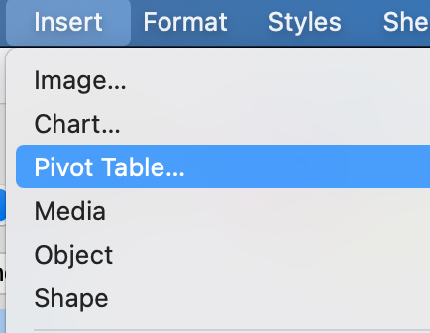
- Choose Current selection.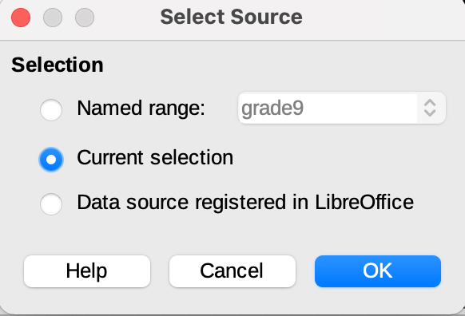
- You will now see this 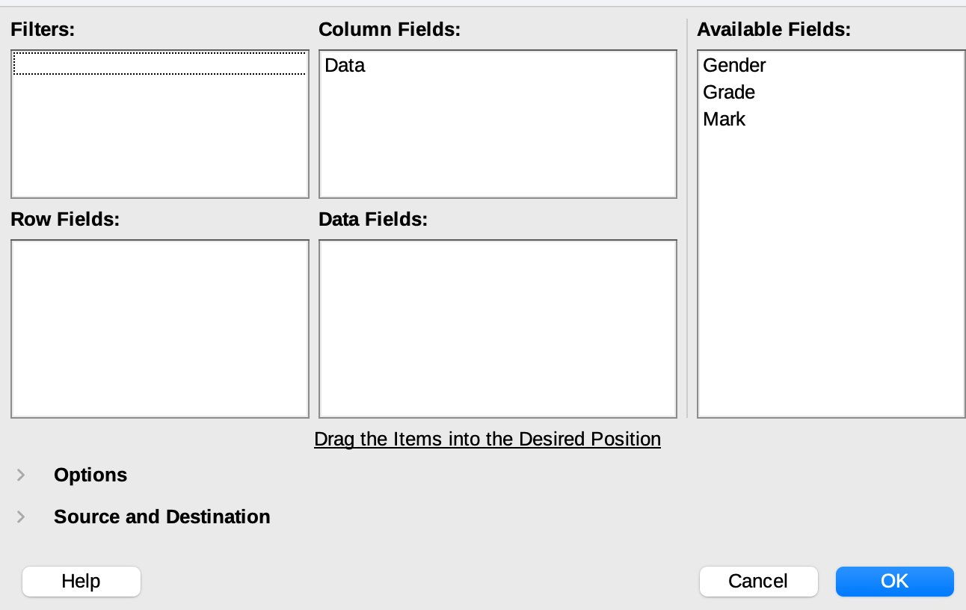
- Now you can use the Pivot tble to calculate
  - The number of students in each class
  - The average mark for each clas
  - The average score for males and females.
- To find the number of students in each class do this
  - Drag Grade in the Row Field box
  - Drag Mark into the Data Fields box
  - Double click on Sum - Mark to change it to Count - Mark.
- 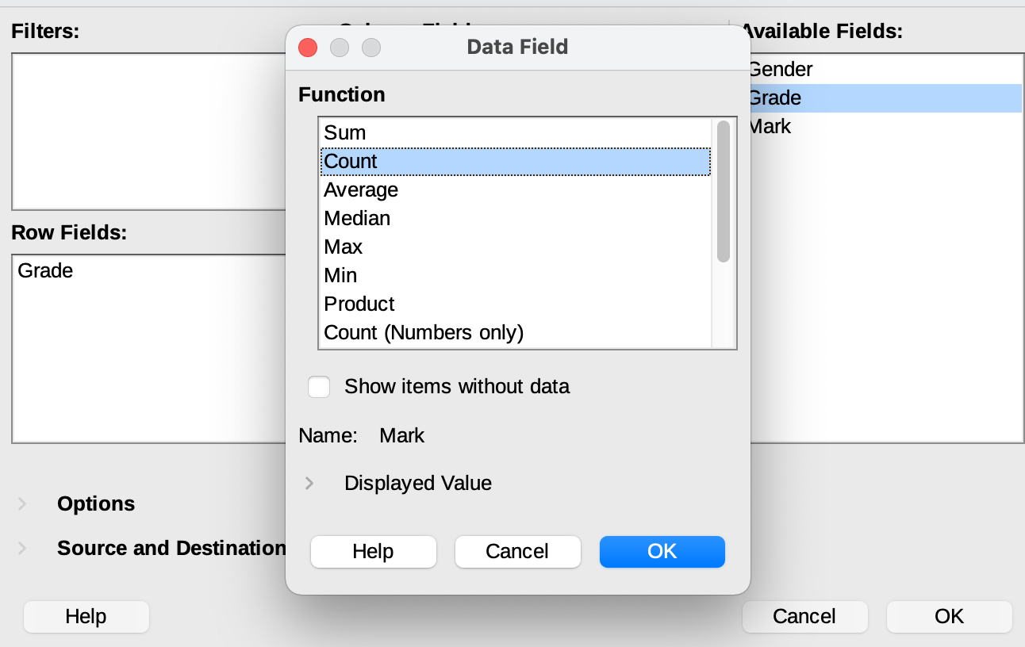
- Click on OK and then click OK again to see this pivot table. 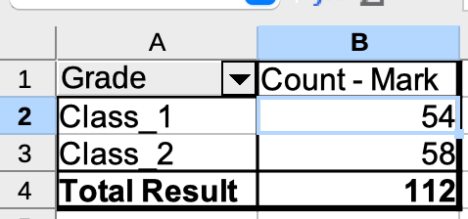
- You can make a Chart by clicking on a cell in the pivot tableand then using Insert -> Chart.
  - Choose Column Chart
  - Click on Next to add a title
  - Click on Finish.
- 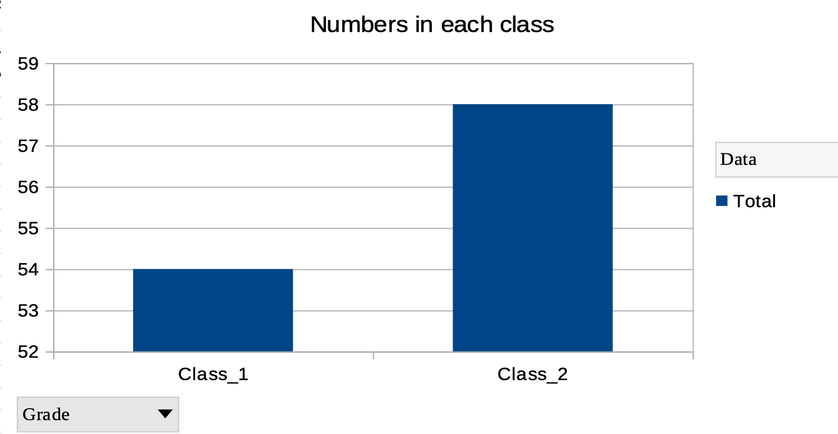
- Now you can easuily add the numbers for gender as well.
  - Click on any cell in the pivot table
  - Right click and edit the table
  - Drag Gender into the Column Fields box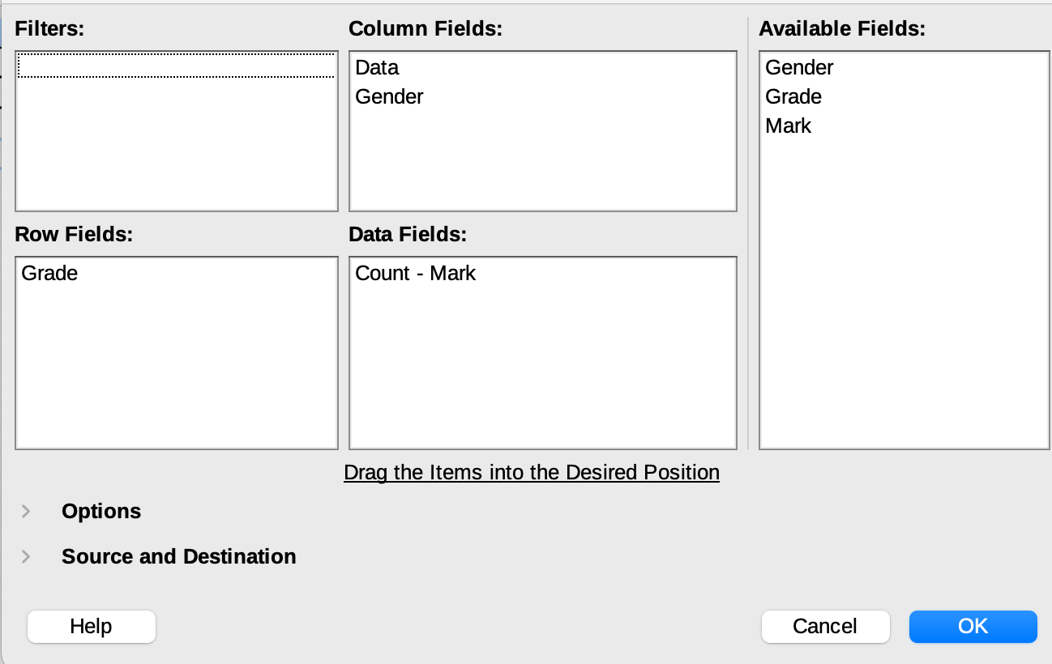
  - Click on OK
- The pivot table and the chart now show the new data.
- Now let's look at the average mark for the classes and genders.
  - Click in the pivot table
  - Right click to edit the table.
  - In the Data Fields box double click on Count - Mark and change it to Average - Mark 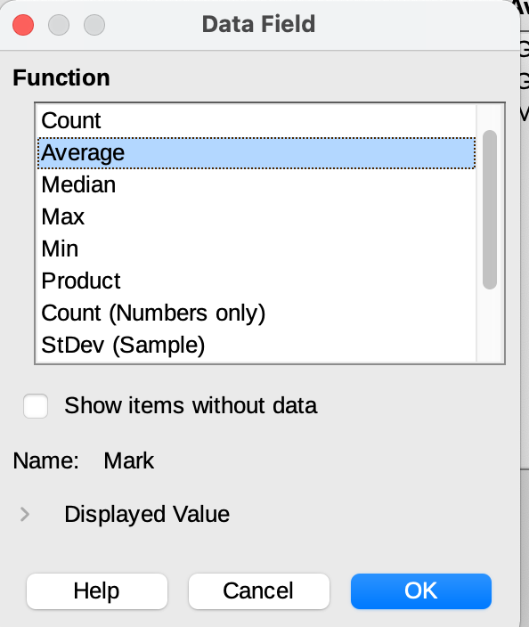
  - Click on OK and OK again
- Change the format of the numbers
  - Select all the numbers in the pivot table
  - Format as number 
- Change the title of the chart by clicking on it and change it to to Average Marks by Class and Gender.
- You can now answer the questions at the top of the page.

